**BANK SYSTEM DOCUMENTATION**

**REQUIREMENTS ELICITATION**

1. **Functional Requirements**
   * Register a customer.
   * Open accounts (Savings, Investment, Cheque).
   * Deposit funds.
   * Withdraw funds.
   * Apply monthly interest (5% for Investment, 0.05% for Savings).
   * Make sure account rules are respected:
     + Savings → *no withdrawals*.
     + Investment → must open with BWP 500.
     + Cheque → only if customer is employed & provides employer info.
   * A customer can have multiple accounts and all three of them if the customer wishes so.
2. **Non-Functional Requirements**
   * Security: system should authenticate users to avoid unauthorized users.
   * Usability: should be simple to use (no overly complex steps).
   * Performance: system should handle multiple customers/accounts smoothly.
   * Solidity: transactions update balances correctly every time.

*INTERVIEW RECORD (APPENDIX A)*

**Interview Questionnaire**

**Date:** [16/09/2025]  
**Interviewer:** Isaac Osenotse  
**Interviewee:** Themba Moeng

**Questions & Answers**

**Qn1.**What types of accounts should the system support?  
**Ans:** Savings, Investment, and Cheque accounts.

**Qn2.** Can one customer have more than one account?  
**Ans:** Yes, a customer can hold multiple accounts, all three types if desired.

**Qn3.** What is required to open an Investment account?  
**Ans:** It must be opened with a minimum deposit of BWP500.

**Qn4.**What is required to open a Cheque account?  
**Ans:** The customer must be employed and must provide employer information such as company name and address.

**Qn5.**What restrictions apply to a Savings account?  
**Ans:** It does not allow withdrawals.

**Qn6.**How should deposits be handled?  
**Ans:** Customers should be able to deposit funds into any of their accounts without restriction.

**Qn7.**How should withdrawals be handled?  
**Ans:** Allowed from Investment and Cheque accounts, but not from Savings accounts.

**Qn8.**What interest rates should apply to accounts?  
**Ans:** Savings accounts: 0.05% monthly. Investment accounts: 5% monthly.

**Qn9.**How should interest be applied?  
**Ans:** Interest is calculated monthly based on the account balance and added automatically to the account.

**Qn10.**What customer details must be recorded?  
**Ans:** At minimum: first name, surname, address, and including employer details for Cheque account holders.

**STRUCTURAL UML MODELLING**

**1.System Use Case Diagram**

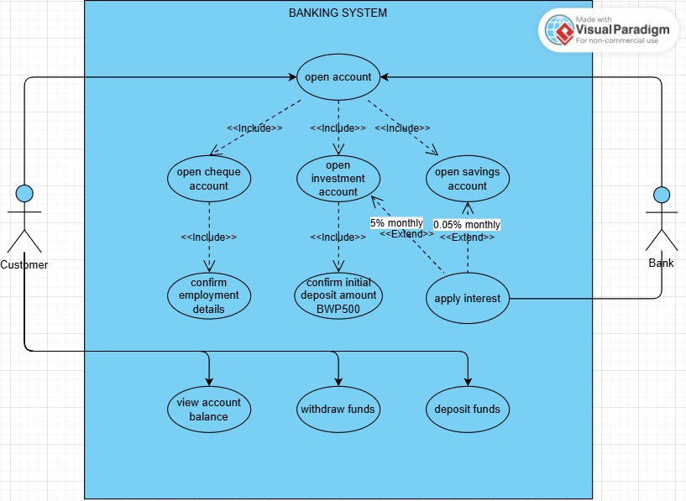

**2. Class Diagram**

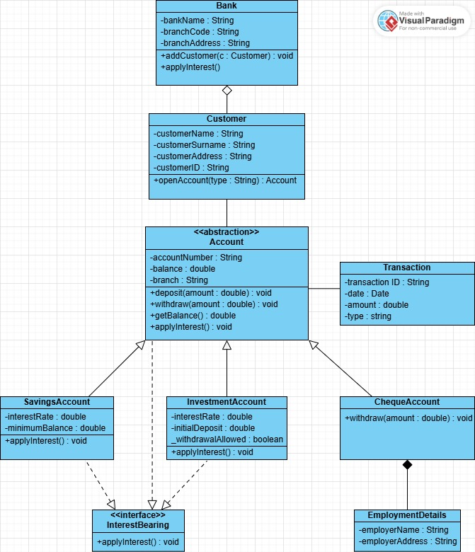

**BEHAVIOURAL UML MODELLING**

**1.Sequence Diagrams**

**a) Deposit Funds  
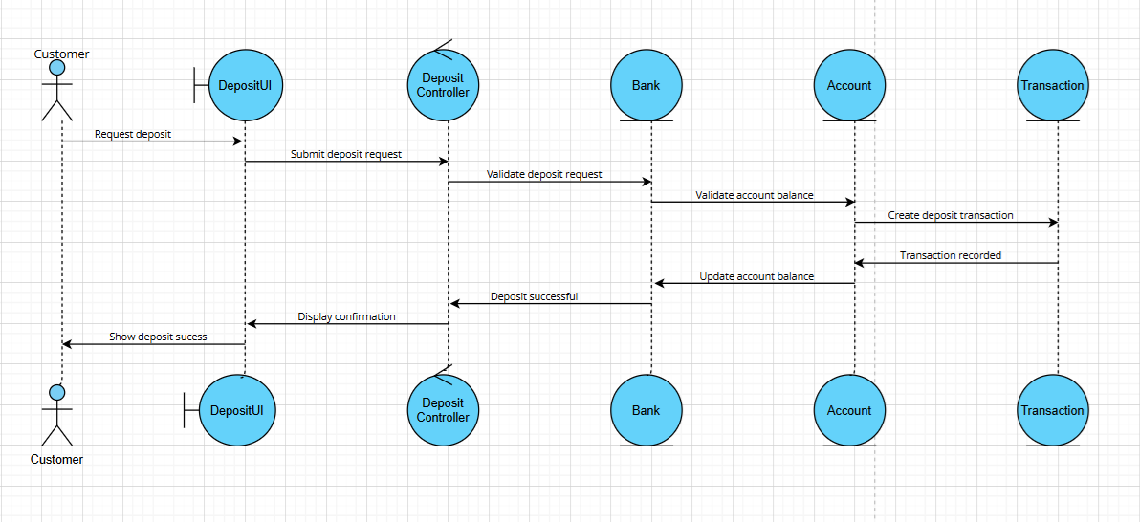**

**b) Withdraw Funds**

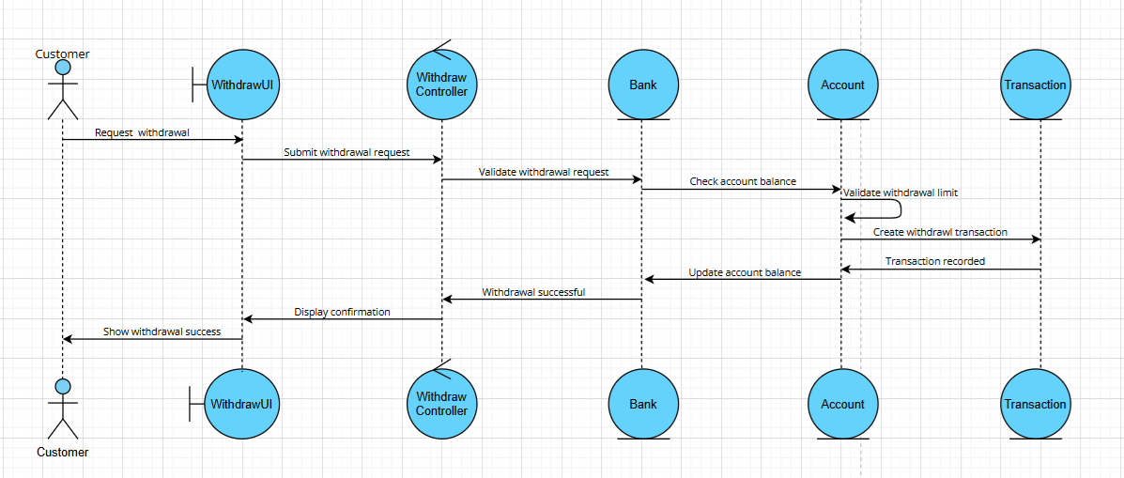

**2.State Diagram**

